**INTRODUCTION TO PROGRAMMING LAB**

**HOMEWORK-1**

**152120171109 OLÇAN SATIR**



**Eskişehir Osmangazi University**

**Faculty of Engineering and Architecture**

**Department of Computer Engineering**

**152111011 Introduction to Programming Lab**

**Lecturer Dr. Yıldıray ANAGÜN**

**November 2020**

**SUMMARY OF MY PROJECTS**

**PROBLEM 1:**   
In this problem, we found out how long a loan with a certain loan amount, interest and payment will be paid.

**PROBLEM 2:**

In this problem we was separate the money collections which is given to us.

**PROBLEM 3:**

In this problem, we encoded a program with the amount of increase, the number to be skipped, and the last number with for, while and do while loops.

**PROBLEMS THAT I ENCOUNTERED**

**PROBLEM 1:**

First, I found the result as a floating point number because I typed %lf instead of %.1 lf.

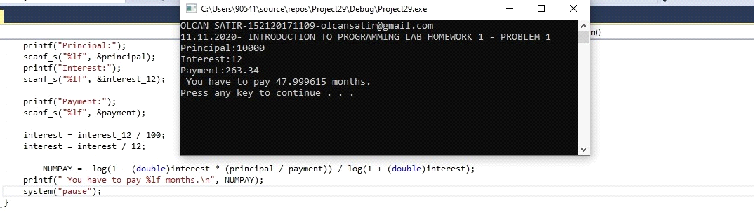

**PROBLEM 2:**

I have forgotten the semicolon lists. Other than that, I had no problem.

**PROBLEM 3:**

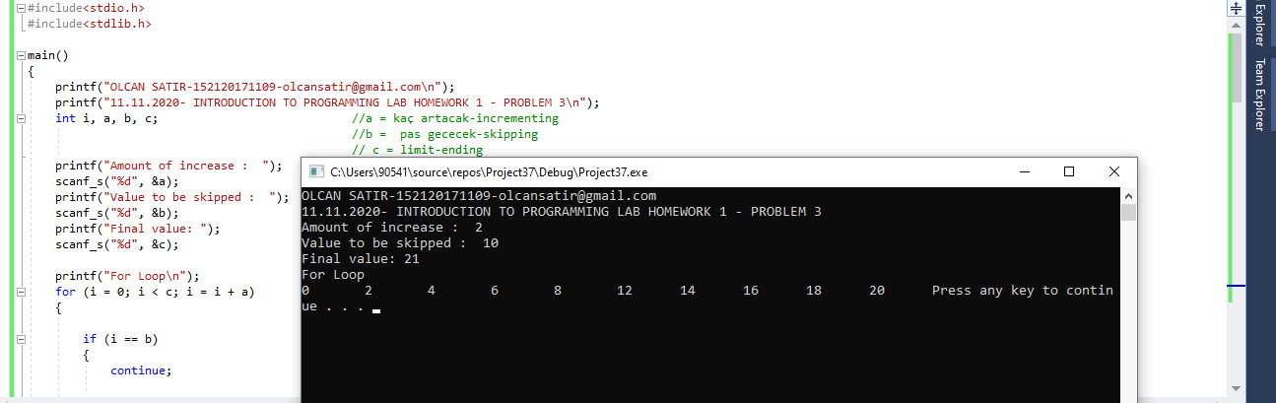

First,I couldn’t to print final value on the screen but after that I used secondly if loop and I printed the final value on the screen.

**ALGORITHM OF THESE PROGRAMS**

**PROJECT 1:**

1)Firstly, I defined variables that I used.

2)Secondly, I wanted to inputs from user to defined variables.

3)Finally, I wrote an equation to calculated to NUMPAY with input which was taken from user.

**PROJECT 2:**

1)Firstly, I defined variables that I used.

2)After that, I wanted to input to assign cents value from user.

3)Lastly,I was separate our variables as collections.

**PROJECT 3:**

1)Firstly, I defined m and n variables that I used.

2)Secondly, I wanted to inputs to assign to “increased value”,”skipped value” and “final value”.

3.1) I was creating a for loop to determine result and two if condition to determine skipped value and printed final value on the screen.

3.2) I was creating a while loop to determine result and two if condition to determine skipped value and printed final value on the screen.

3.3) I was creating a do-while loop and two if condition to determine skipped value and determine a result and printed final value on the screen.

**FLOWCHARTS OF THESE PROGRAMS**

**ANSWER 1:**

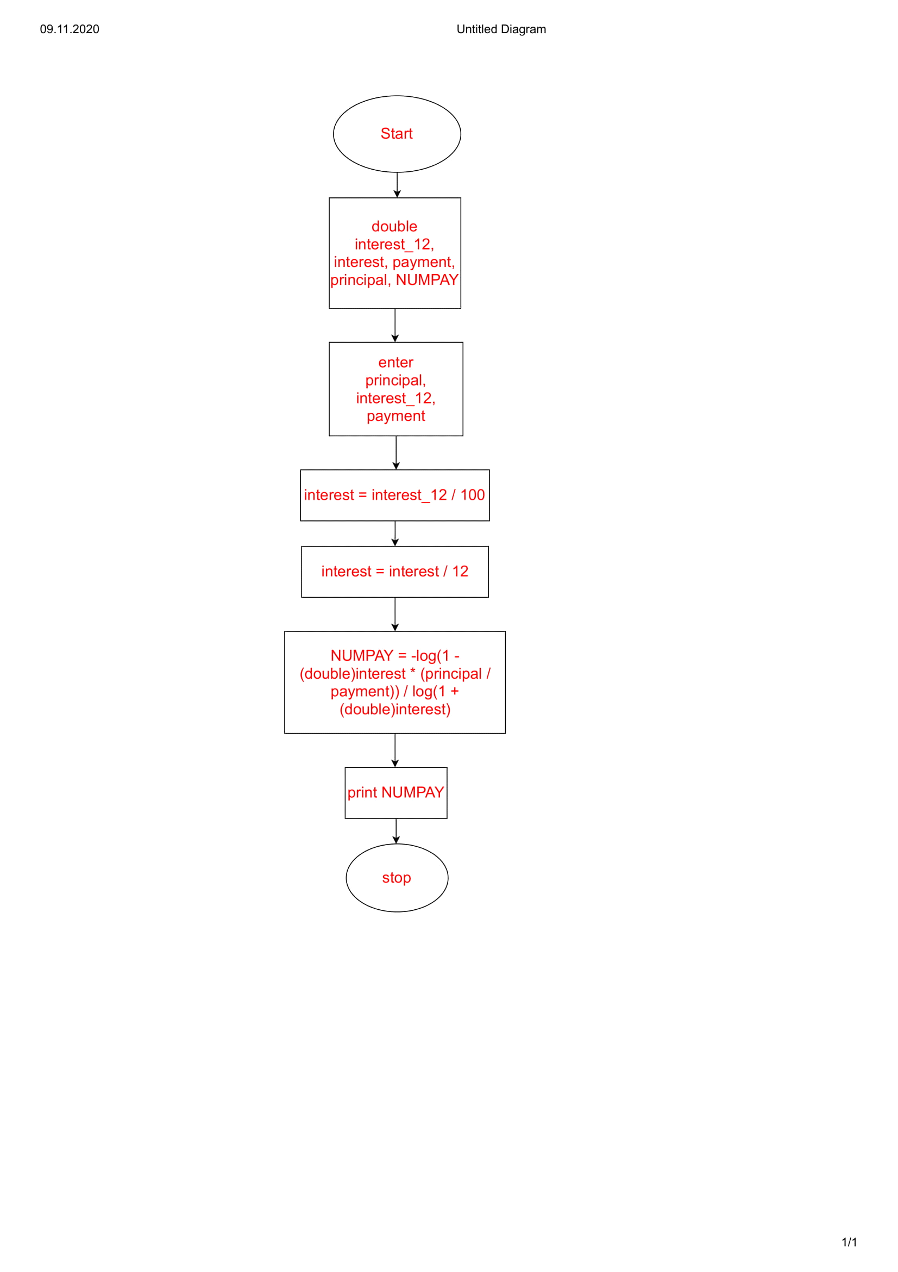

**ANSWER 2:**

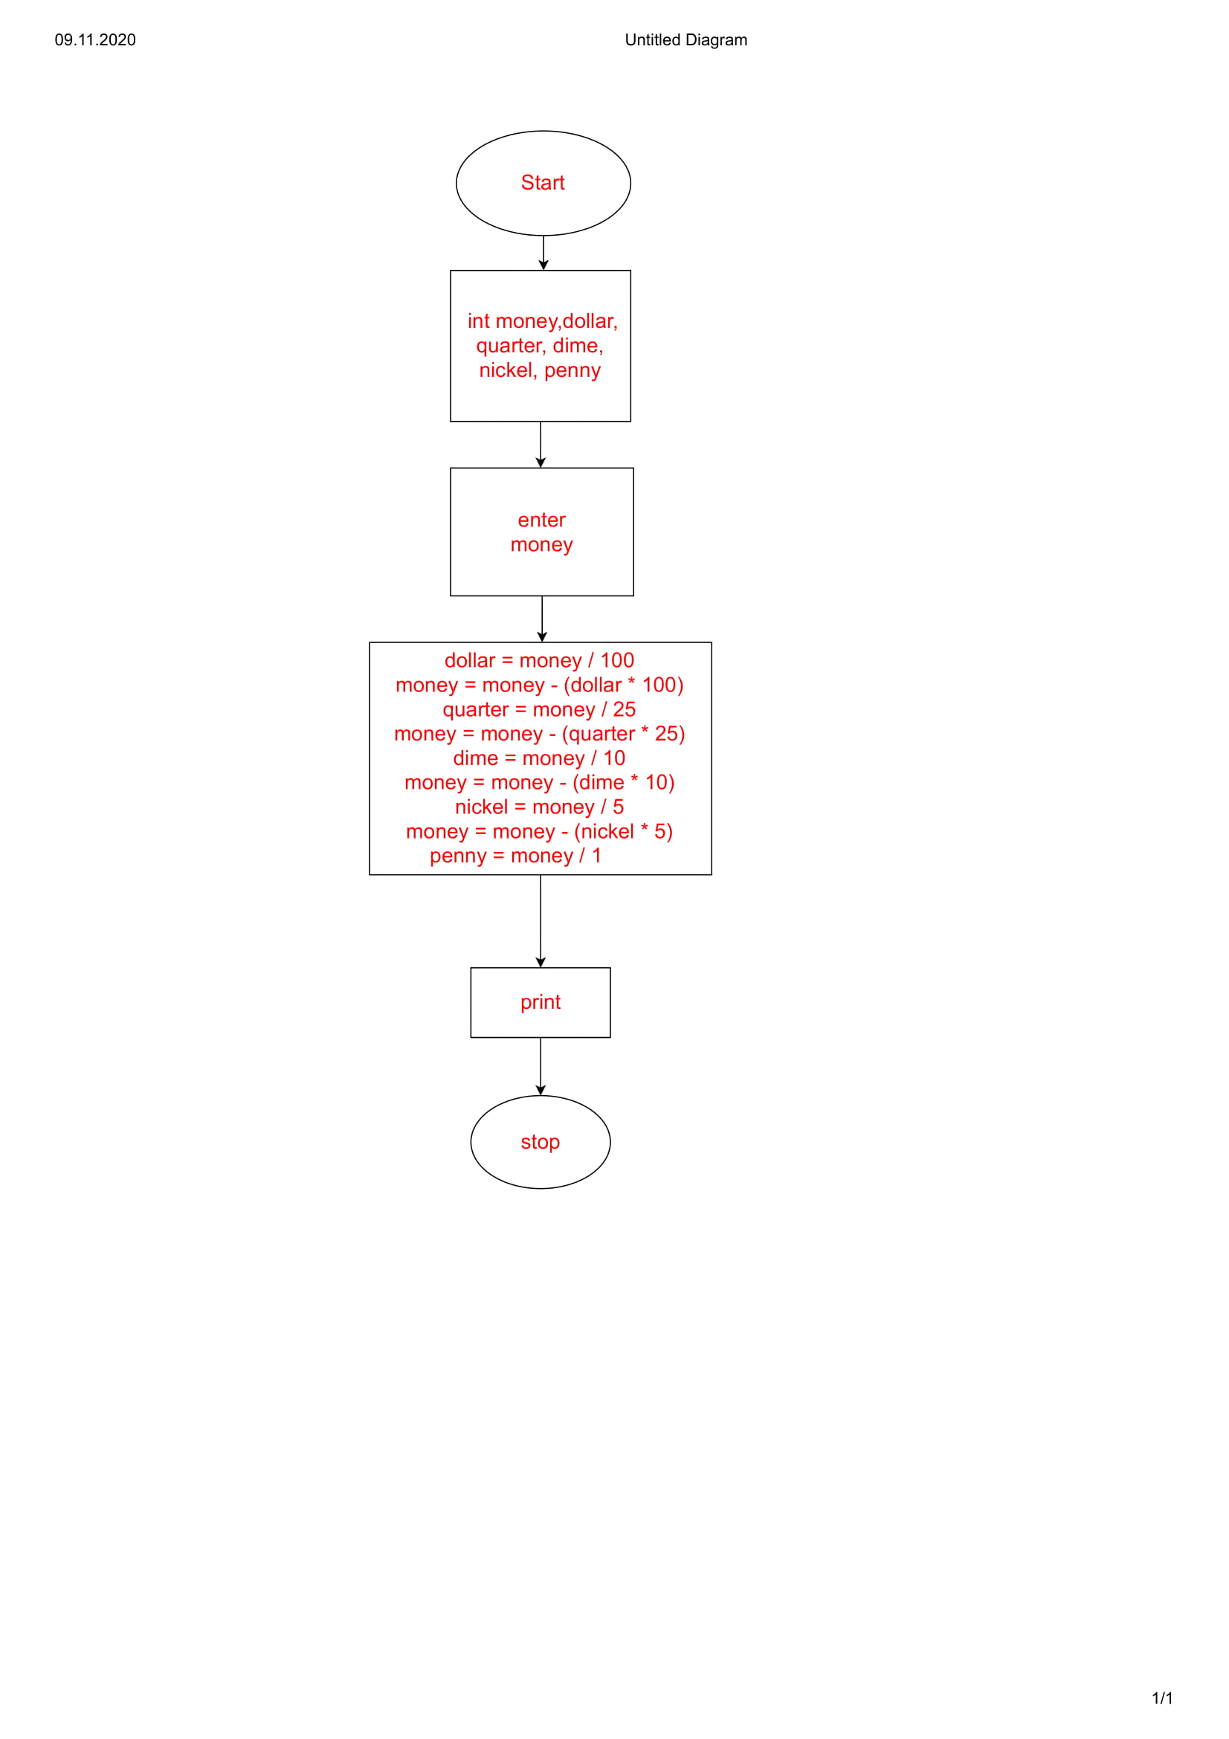

**ANSWER 3:**

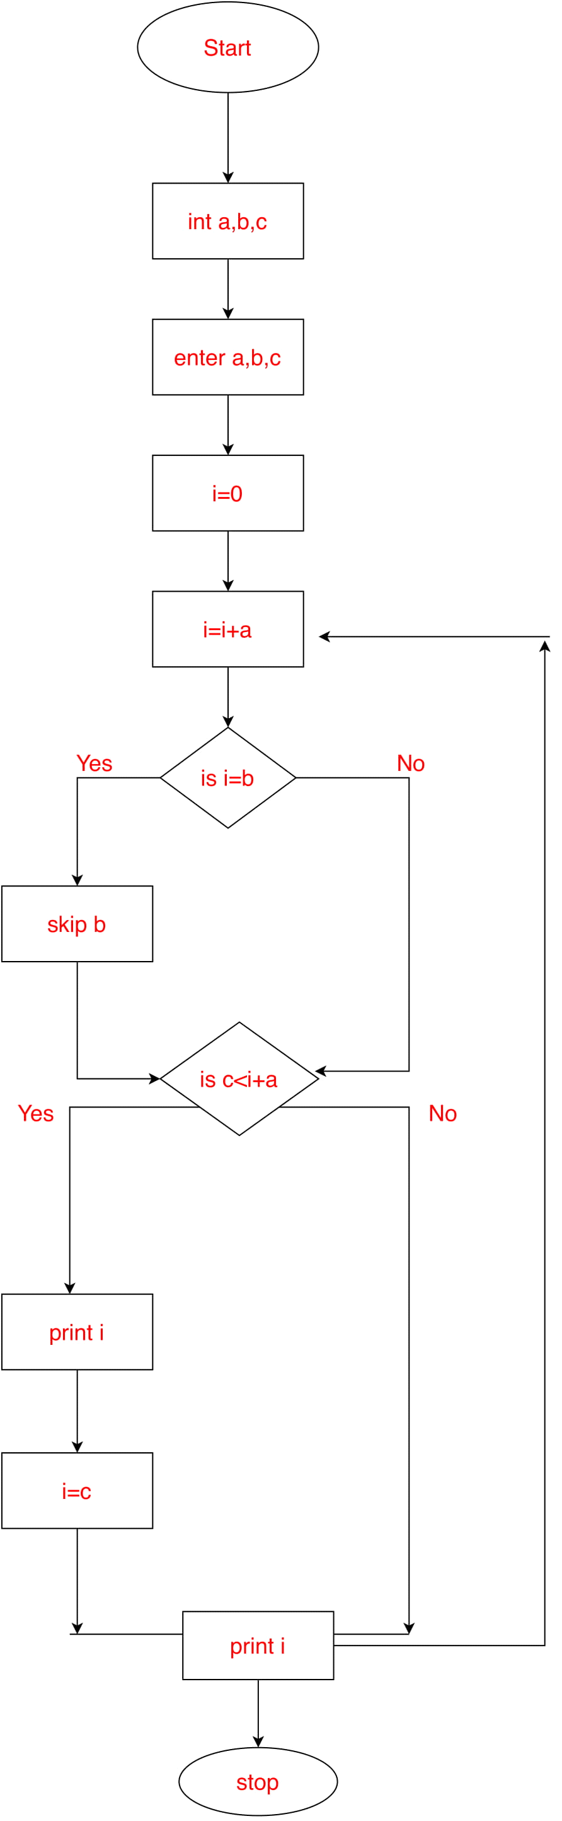

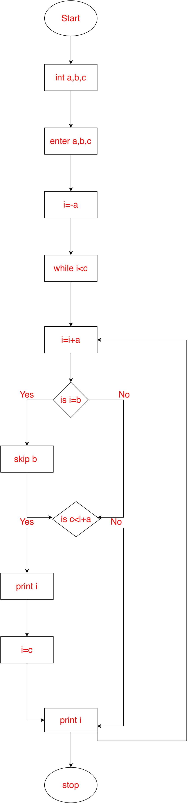

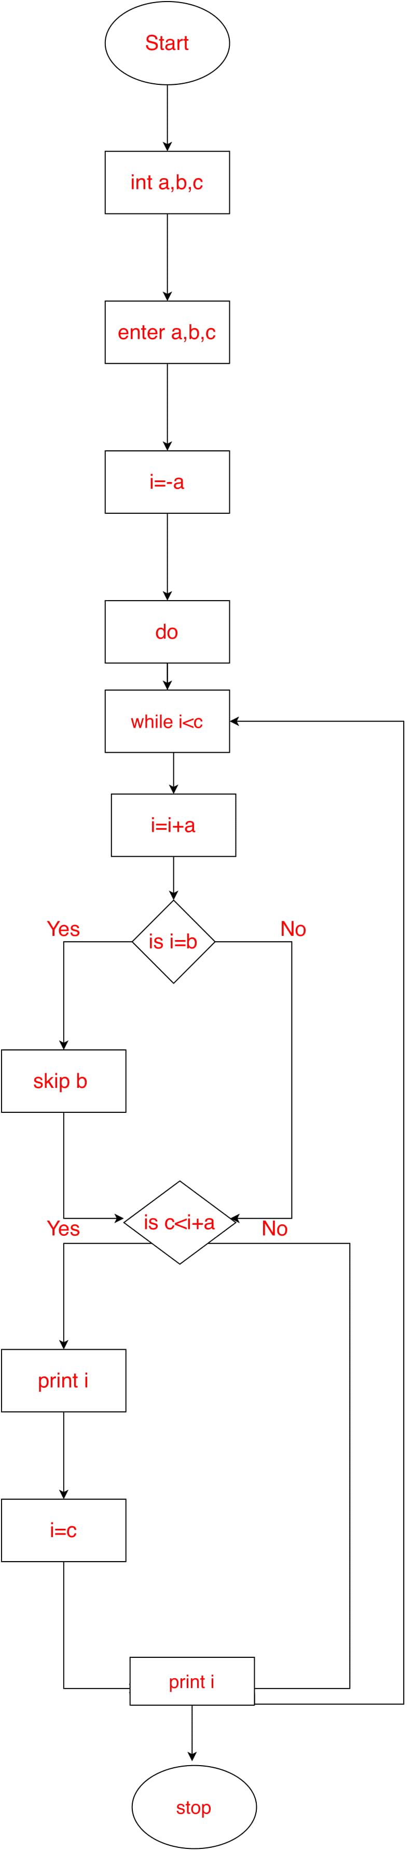

**CODES OF THE PROGRAMS**

**ANSWER 1:**

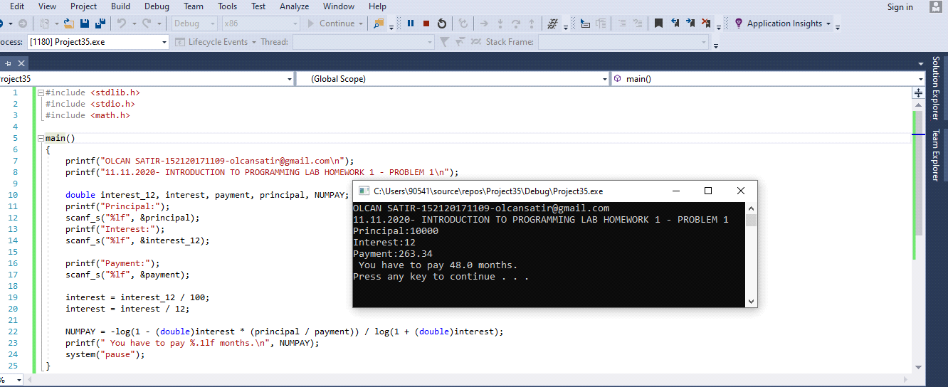

**ANSWER 2:**

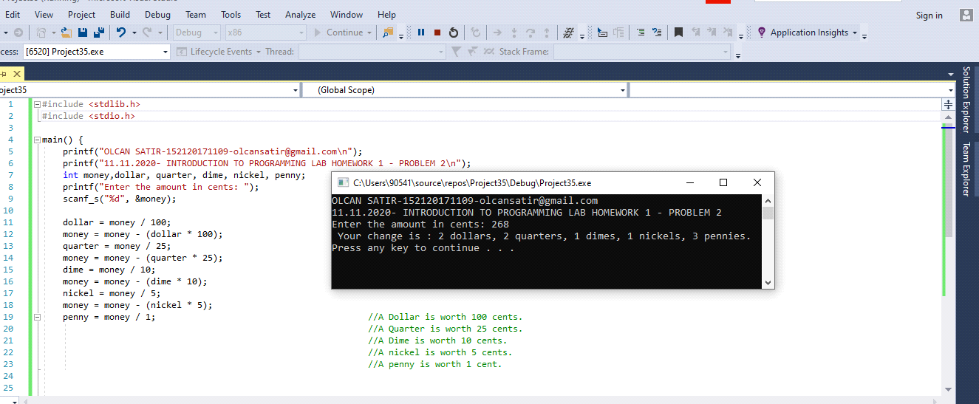

**ANSWER 3:**

